Melbourne, Arkansas
April 6, 2021

The meeting will come to order
The Clerk will call roll
Prayer and Pledge of Allegiance
Reading of last month’s minutes

AGENDA
Comments from the audience (three minutes per person)

NEW BUSINESS:
- Resolution to Enter a Contract
- 2020 Budget Cleanup Ordinance
- Resolution for Liberty of Rights
- Car Donation
- Road Update

OLD BUSINESS:

ADJOURN
IZARD COUNTY JUDGE

IZARD COUNTY QUORUM COURT
March 2021

Izard County Quorum Court met in regular session on Tuesday, March 2 at 6:00 p.m. Justices Sanders, Hagan, Sherrell, Moser, Miller, Engelhardt, Everett, and Emmens were present.
The minutes of the February meeting were approved on a motion by Justice Miller and second by Justice Emmens with all in favor.
Ordinance # 2021-2, an ordinance appropriating grant funds into the Comprehensive Opioid, Stimulant, and Substance Abuse Program grant budgets was approved on a motion by Justice Miller and a second by Justice Moser with all justices voting in favor.
Resolution # 2021-2, a resolution authorizing the county judge of Izard County to submit an application to the Arkansas Economic Development Commission for a Coronavirus related project was approved on a motion by Justice Everett and a second by Justice Miller with all justices voting in favor.
Resolution # 2021-3, a resolution authorizing the county judge of Izard County enter into an administrative agreement with the Arkansas Economic Development Commission was approved on a motion by Justice Everett and a second by Justice Moser with all justices voting in favor.
Ordinance # 2021-3, an ordinance to amend ordinance # 81-6 to change the amount in the collector’s change fund from $100 to $300 was placed on a second and third reading by title only and was approved on a motion by Justice Moser and a second by Justice Hagan with all justices voting in favor.
The court voted to accept the recommendation of the Izard County EMS District Board of Directors that the county extend the contract with the current ambulance provider, Vital link, for five (5) years on a motion by Justice Miller and a second by Justice Hagan with all justices voting in favor.
Judge Eric Smith stated that since the county road department had been dealing with the heavy snow that the county received in February, there was no county road report for the month of February.
With no other business, the court adjourned at 6:28 pm.
DATED:

COUNTY JUDGE: COUNTY CLERK:
RESOLUTION NO. _________

A RESOLUTION AUTHORIZING THE
COUNTY JUDGE OF IZARD COUNTY,
ARKANSAS, TO ENTER INTO A
CONTRACT FOR SENIOR CITIZENS
IMPROVEMENTS.

WHEREAS, Izard County received bids for kitchen equipment and HVAC equipment for the senior citizens center. The funding for the construction project is being provided by a grant from the Arkansas Economic Development Commission. All bids have been received and a recommendation for award has been made by the county’s engineer.

WHEREAS, it is necessary for the County Judge to sign the construction contract prior to execution of the work;

NOW, THEREFORE, IT IS RESOLVED that the Quorum Court of Izard County, Arkansas, hereby declares that the County Judge be authorized to execute a contract with Wades Heating and Cooling of Batesville, Arkansas for kitchen equipment in an amount not to exceed Eighty-Eight Thousand Five Hundred and No/100 Dollars ($88,500.00) and with Crawford Builders of McCrory, Arkansas for HVAC units for an amount not to exceed Twenty-eight Thousand Ninety-Nine and No/100 Dollars ($28,099.00).

Said contract amount not to be changed without properly executed change orders.

ENTERED this day of April, 2021.

County Judge

County Clerk

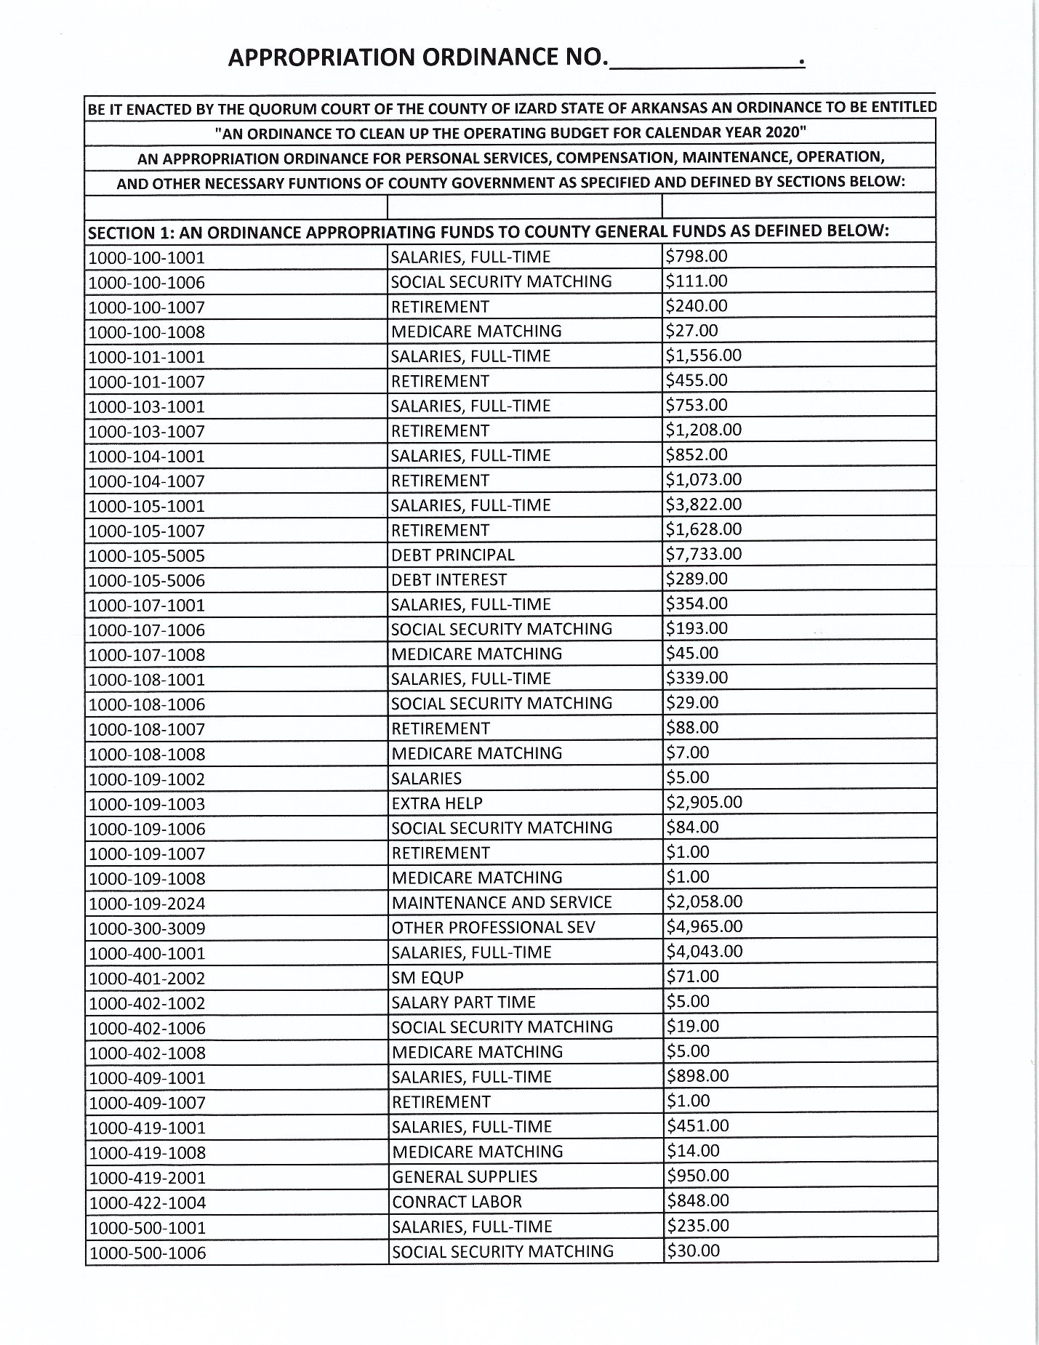

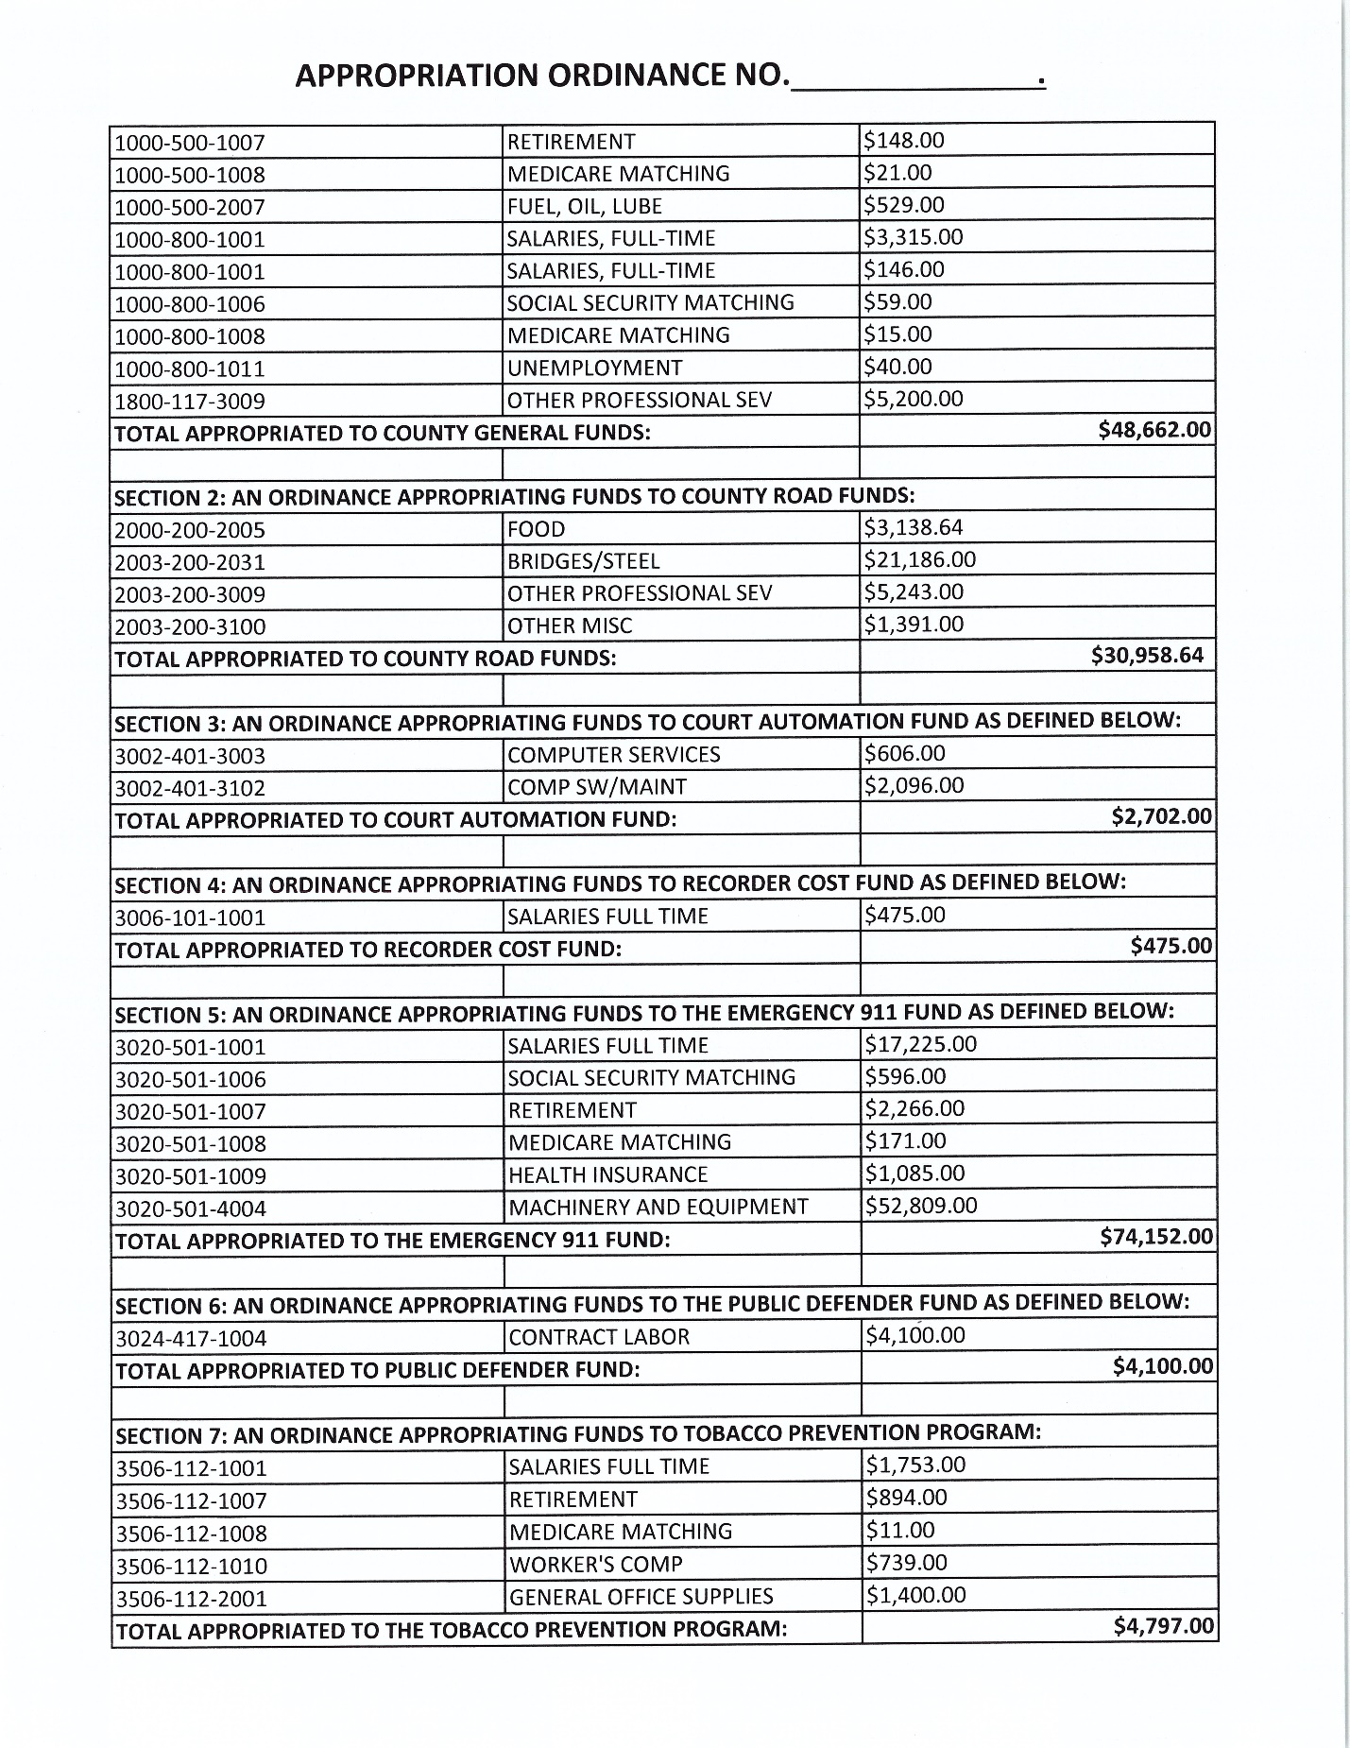

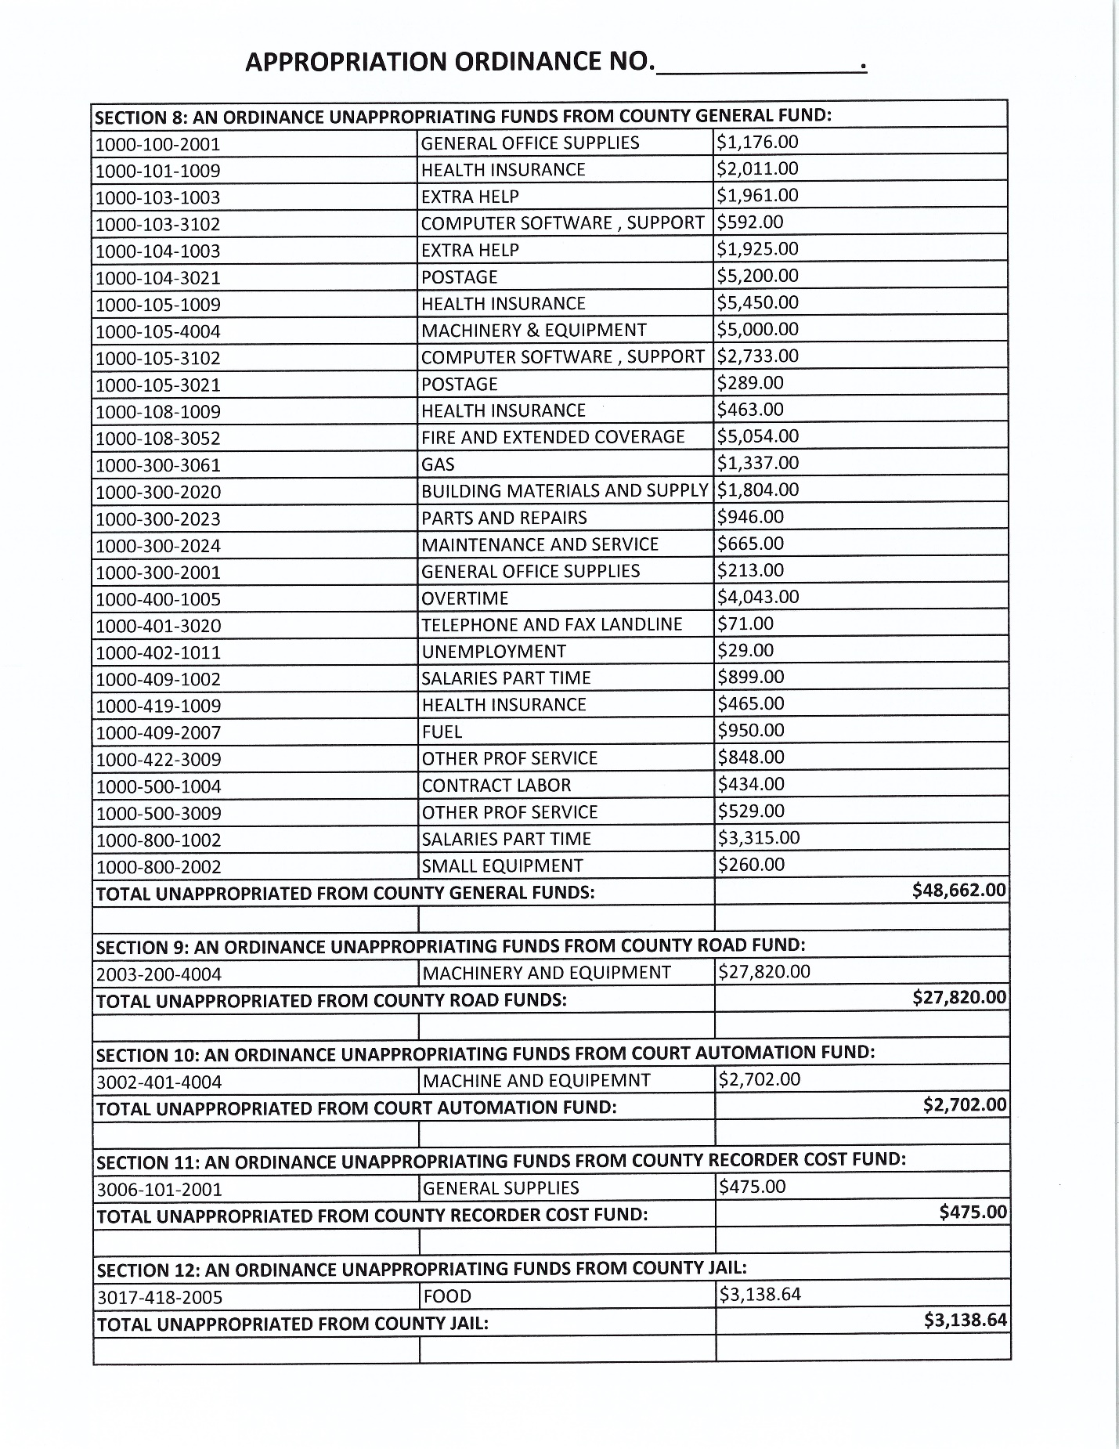

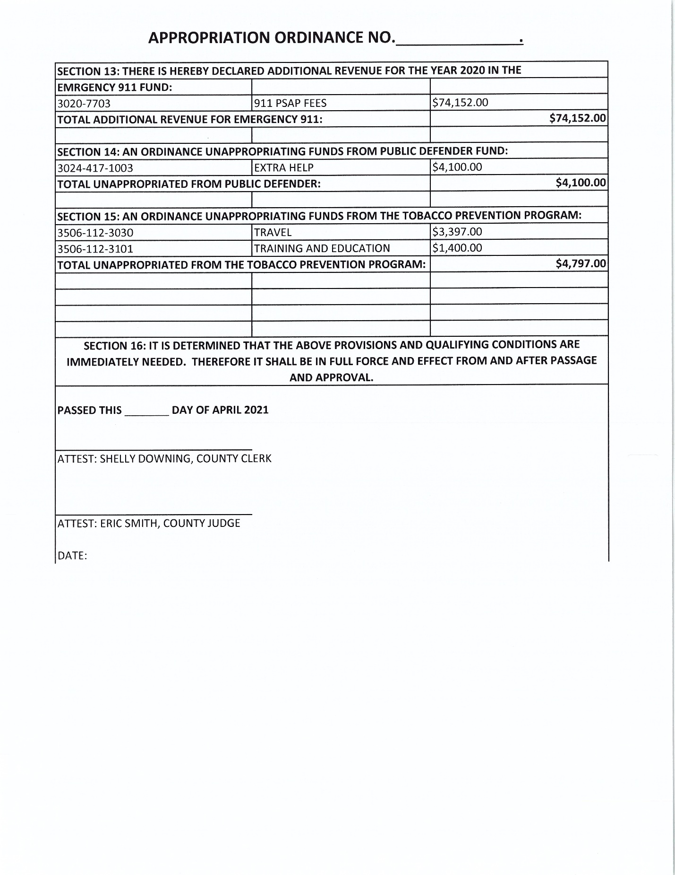

RESOLUTION _______________
“SECOND AMENDMENT COUNTY” RESOLUTION
Affirming Izard County’s Effort to
“Guard Against Any Encroachment On”
Individual Liberty Rights Enumerated in
The U.S. Bill of Rights and the Arkansas Declaration of Rights,
Including but Not Limited to
THE RIGHT TO “KEEP AND BEAR ARMS.”
WHEREAS, Izard County residents have a long standing belief in the Bill of Rights in the United States Constitution and the Declaration of Rights in the Arkansas Constitution;
WHEREAS, as elected officials, we are sworn to uphold both the U.S. Constitution and the Arkansas Constitution in our Oath of Office.
WHEREAS, it seems that several of our time-honored, individual liberty rights enumerated in the U.S. Constitution and the Arkansas Constitution are under attack; particularly, the right to keep and bear arms.
Rights of the People
WHEREAS, it is plainly stated in the U.S. Constitution, Amendment 9: The enumeration in the Constitution, of certain rights, shall not be construed to deny or disparage others retained by the people.
WHEREAS, it is plainly stated in the Arkansas Constitution, Article 2, Section 29: Enumeration of Rights of People Not Exclusive of Other Rights – Protection Against Encroachment – “This enumeration of rights shall not be construed to deny or disparage others retained by the people; and to guard against any encroachments on the rights herein retained, or any transgression of any of the higher powers herein delegated, we declare that everything in this article is excepted out of the general powers of the government; and shall forever remain inviolate; and that all laws contrary thereto, or to the other provisions herein contained, shall be void.”
Right to Keep and Bear Arms
WHEREAS, it is plainly stated in the U.S. Constitution, Amendment 2: “A well-regulated Militia, being necessary to the security of a free State, the right of the people to keep and bear Arms, shall not be infringed.”
WHEREAS, it is plainly stated in the Arkansas Constitution, Article 2, Section 5: Right to Bear Arms – “The citizens of this State shall have the right to keep and bear arms, for their common defense.”
Right of Due Process
WHEREAS, it is plainly stated in the U.S. Constitution, Amendment 5: No person shall be…deprived of life, liberty, or property without due process of law…
WHEREAS, it is plainly stated in the U.S. Constitution, Amendment 14, Section 1: … No State shall make or enforce any law which shall abridge the privileges or immunities of citizens of the United States; nor shall any State deprive any person of life, liberty, or property, without due process of law…; nor deny to any person within its jurisdiction the equal protection of the laws.
WHEREAS, it is plainly stated in the Arkansas Constitution, Article 2, Section 8: Criminal Charges – Self-Incrimination – Due Process – Double Jeopardy – Bail – No person shall be…deprived of life, liberty or property, without due process of law…
WHEREAS, it is plainly stated in the Arkansas Constitution, Article 2, Section 13: Redress of Wrongs – Every person is entitled to a certain remedy in the laws for all injuries or wrongs he may receive in his person, property or character; he ought to obtain justice freely, and without purchase; completely, and without denial; promptly and without delay; conformably to the laws.
WHEREAS, it is plainly stated in the Arkansas Constitution, Article 2, Section 21: Life, Liberty and Property – Banishment Prohibited – No person shall be… deprived of his life, liberty or property; except by the judgment of his peers, or the law of the land … .
Right of Equal Protection
WHEREAS, it is plainly stated in the U.S. Constitution, Amendment 14, Section 1: …No State shall …deny to any person within its jurisdiction the equal protection of the laws.
WHEREAS, it is plainly stated in the Arkansas Constitution, Article 2, Section 2: Freedom and Independence – All men are created equally free and independent, and have certain inherent and inalienable rights; amongst which are those of enjoying and defending life and liberty; of acquiring, possessing and protecting property, and reputation; and of pursuing their own happiness. To secure these rights governments are instituted among men, deriving their just powers from the consent of the governed.
WHEREAS, it is plainly stated in the Arkansas Constitution, Article 2, Section 18: Privileges and Immunities – Equality – The General Assembly shall not grant to any citizen, or class of citizens, privileges or immunities which, upon the same terms, shall not equally belong to all citizens.
WHEREAS, it is plainly stated in the Arkansas Constitution, Article 2, Section 3: The equality of all persons before the law is recognized, and shall ever remain inviolate; nor shall any citizen ever be deprived of any right, privilege or immunity; nor exempted from any burden or duty, on account of race, color or previous condition.
Right Against Unreasonable Search and Seizure
WHEREAS, it is plainly stated in the U.S. Constitution, Amendment 4: The right of the people to be secure in their persons, houses, papers, and effects, against unreasonable searches and seizures, shall not be violated, and no Warrants shall issue, but upon probable cause, supported by Oath or affirmation, and particularly describing the place to be searched, and the persons or things to be seized.
WHEREAS, it is plainly stated in the Arkansas Constitution, Article 2, Section 15: Unreasonable Searches and Seizures – The right of the people of this State to be secure in their persons, houses, papers, and effects, against unreasonable searches and seizures, shall not be violated; and no warrant shall issue, except upon probable cause, supported by oath or affirmation, and particularly describing the place to be searched, and the person or thing to be seized.
Powers of the State
WHEREAS, it is plainly stated in the U.S. Constitution, Amendment 10: The powers not delegated to the United States by the Constitution, nor prohibited by it to the states, are reserved to the states respectively, or to the people.
WHEREAS, it is plainly stated in the U.S. Constitution, Article 2, Section 1: Source of Power – All political power is inherent in the people and government is instituted for their protection, security and benefit; and they have the right to alter, reform or abolish the same, in such manner as they may think proper.
WHEREAS, it is plainly stated in the Arkansas Constitution, Article 2, Section 12: Suspension of Laws – No power of suspending or setting aside the law or laws of the State, shall ever be exercised, except by the General Assembly.
Sworn Duty of County Officials and Officers
WHEREAS, in order to uphold our sworn duty, we are bound to follow and enforce support of all of the provisions in the U.S. Constitution Bill of Rights and the Arkansas Constitution Declaration of Rights;
WHEREAS, it is our duty to do our part to guard against any unconstitutional denial of, disparagement of, or encroachment on any of the enumerated or unenumerated rights retained by the people;
NOW, THEREFORE, BE IT RESOLVED BY THE QUORUM COURT OF IZARD COUNTY, ARKANSAS, THAT:
- As an expression of Izard County’s desire to join the present nationwide effort to affirmatively state county government support for the U.S. Constitution, Bill of Rights, Second Amendment, and the statewide effort to affirmatively state county government support for the Arkansas Constitution, Declaration of Rights, Section 5, as plainly written and historically interpreted and applied, let it be resolved and known that Izard County, Arkansas, is hereby designated a “Second Amendment County.”
2. Izard County shall uphold each and every provision of the Bill of Rights in the U.S. Constitution and the Declaration of Rights in the Arkansas Constitution and, specifically, Izard County shall uphold the right of the citizens of this county to “keep and bear arms” as guaranteed by the U.S. Constitution, Amendment 2, and the Arkansas Constitution, Declaration of Rights Article 2, Section 5.

3. It is declared to be the official policy of Izard County that the U.S. Second Amendment right and the Arkansas Article 2, Section 5, right of citizens to keep and bear arms will be honored by the officials, officers and employees of Izard County as a constitutionally- protected individual liberty right and that any act of any legislature that plainly abrogates U.S. Constitution Amendment 2 or Arkansas Constitution Declaration of Rights, Article 2, Section 5, will be treated as void and, therefore, unenforceable in Izard County.

4. Since it is clear from both U.S. Constitution Amendment 9 and Arkansas Constitution Article 2, Section 29, that individual liberty rights belong to the people and are to be forever retained by the people and not transgressed by any of the powers delegated to either the U.S. or Arkansas governments, Izard County shall neither interpret nor construe any legislation in any manner that would deny or disparage the Bill of Rights or the Declaration of Rights and shall guard against any encroachments on the U.S. Bill of Rights and the Arkansas Declaration of Rights.

5. Izard County agrees with and supports the U.S. Constitution Amendment 9 and Arkansas Constitution Article 2, Section 29 concepts that the individual liberty rights enumerated in the U.S. Bill of Rights and the Arkansas Declaration of rights are excepted out of the general powers of the government and shall forever remain inviolate.

6. Izard County shall obey the Constitutions of the U.S. and Arkansas, including the Tenth Amendment police powers as needed to maintain order, ensure security, and keep the peace, all as limited by the Fourth Amendment right of every person to be free from unreasonable searches and seizures and the Fourteenth Amendment promise that no person will be deprived of life, liberty or property except by due process of law.

CERTIFICATION OF ADOPTION OF RESOLUTION

The undersigned Clerk of the County Court of Izard County, Arkansas, hereby certifies
that the Resolution set forth above was adopted during an open meeting on the ___________
day of ______________________, 2021, by the Quorum Court with the following votes:
Aye: __________
Nay: __________
Abstentions: ___________
Absent: ________
Signed this _____________ day of _______________________ 2021.
BY: ________________________________________
COUNTY JUDGE ERIC SMITH

ATTEST: ____________________________________
COUNTY CLERK SHELLY DOWNING

